15) Design an interactive presentation in Figma explaining the issues in mobile IP.

Aim:
To Design an interactive presentation in Figma explaining the issues in mobile IP

Procedure:

- Define Presentation Structure
- Create a Figma Project
- Design Visual Elements
- Make it Interactive
- Add Annotations and Explanations
- Incorporate Multimedia
- Storyboard Animation
- Test the Prototype
- Collaborate and Gather Feedback
- Finalize and Share

Step By Step Procedure :

Interface Of Experiment:


Next Page:

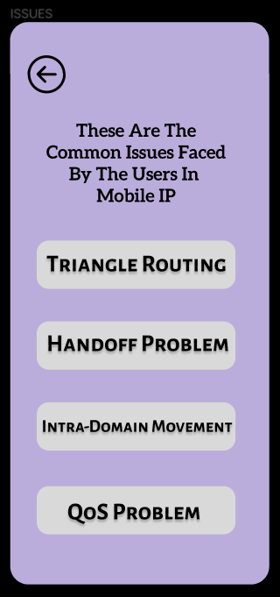

Final Step:

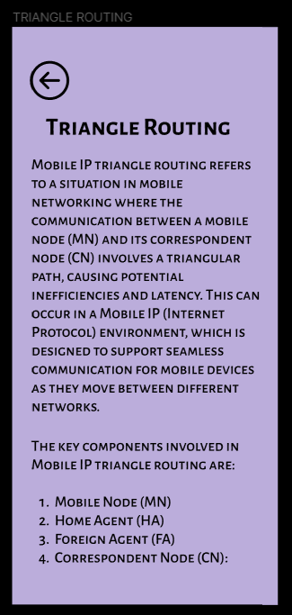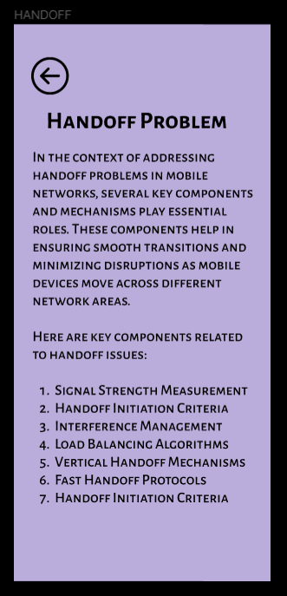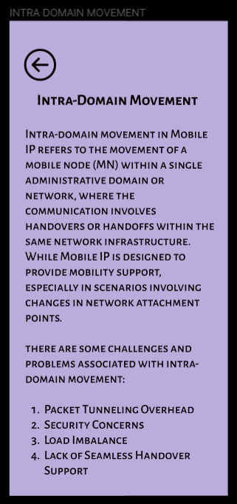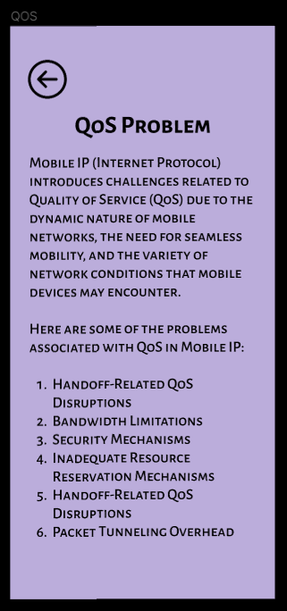
Prototype:

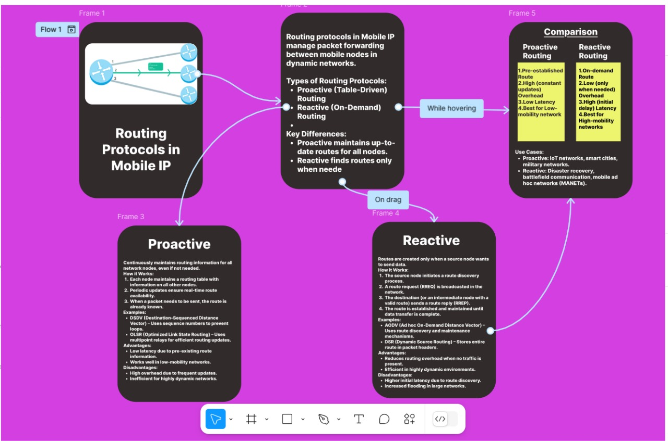

Result:
Hence the interactive presentation in Figma explaining the issues in mobile IP is created and executed successfully.

